Responsive portfolio Website
Aim
To design and develop a modern, responsive portfolio website that showcases personal skills, projects, achievements, resume, and contact information in an attractive and user-friendly manner. The website should adapt seamlessly to different screen sizes such as desktops, tablets, and mobile devices, ensuring accessibility, responsiveness, and enhanced user experience.
Abstract
A responsive portfolio website is a personal web application created to present an individual’s professional profile, technical skills, educational background, and project work on an online platform. The main objective of this project is to build a visually appealing and fully responsive website using modern web technologies such as HTML, CSS, JavaScript, and frameworks like Bootstrap if required.
LINKS
Code_link: https://github.com/VENKY-20302/Venky
Hosted_link: https://venky-20302.github.io/Venky/?#contact

Algorithm
HTML
<!DOCTYPE html>
<html lang="en">
<head>
<title>Venkatesh | Portfolio</title>

<!-- Bootstrap CSS -->
<link
href="https://cdn.jsdelivr.net/npm/bootstrap@5.3.2/dist/css/bootstrap.min.css"
rel="stylesheet"
integrity="sha384-GNFcawzzUrMOepuH0TkI8JkYqN4nAxqJDn7G4GqQinr5xFzZs6qg6h/PYk93©"
crossorigin="anonymous"
/>

<!-- Font Awesome for Icons -->
<link
rel="stylesheet"
href="https://cdnjs.cloudflare.com/ajax/libs/font-awesome/6.4.0/css/all.min.css"
/>

<link rel="stylesheet" href="style.css" />
</head>
<body>
<!-- Right Side Navigation Bar -->
<nav class="navbar-right" id="navbarRight">
<div class="navbar-right-content">
<a href="#home" class="nav-link-right">Home</a>
<a href="#about" class="nav-link-right">About</a>
<a href="#skills" class="nav-link-right">Skills</a>
<a href="#projects" class="nav-link-right">Projects</a>
<a href="#contact" class="nav-link-right">Contact</a>
</div>
</nav>

<!-- Toggle Button for Mobile -->
<button class="navbar-toggle-btn" id="navToggle" onclick="toggleNavbar()">
<i class="fas fa-bars"></i>
</button>
<header class="bg-dark text-white py-5" id="home">
<div class="container text-center">
<h1 class="display-4">Venkatesh</h1>
<p class="lead mb-0">Web Developer | UI/UX Designer | Freelance Creator</p>
</div>
</header>

<main class="container my-5">
<section class="row align-items-center mb-5" id="about">
<div class="col-lg-6">
<h2>About Me</h2>
<p>
Hi, am currently pursuing a B-tech in data science with strong web development and problemsolving skills, skilled in python,html,css, javaScript. Experimental in building frontend and
backend project technologies
and improved problem-solving Gained basic knowledge of skills
</p>
<p>
I love turning ideas into digital experiences that look great on every screen.
</p>
<a href="#contact" class="btn btn-primary">Contact Me</a>
</div>
<div class="col-lg-6 text-center ">
<div class="profile-card p-4">
<img src="c:\Users\user\Downloads\WhatsApp Image 2026-05-11 at 7.11.34 PM.jpeg" alt="Venkatesh" class="rounded-circle mb-3 profile-img" />
<h3 class="mb-1">Venkatesh</h3>
<p class="text-muted mb-0">Front-End Enthusiast</p>
</div>
</div>
</section>

<section class="mb-5" id="skills">
<h2 class="mb-4">Skills</h2>
<div class="row g-3">
<div class="col-md-4">
<div class="card h-100 p-3">
<h5>Front-End</h5>
<p>Bootstrap, HTML5, CSS3, JavaScript, React</p>
</div>
</div>
<div class="col-md-4">
<div class="card h-100 p-3">
<h5>Design</h5>
<p>UI/UX, Responsive Layouts, Figma, Wireframing</p>
</div>
</div>
<div class="col-md-4">
<div class="card h-100 p-3">
<h5>Tools</h5>
<p>Git, VS Code, Chrome DevTools, Webpack</p>
</div>
</div>
</div>
</section>

<section class="mb-5" id="projects">
<h2 class="mb-4">Projects</h2>
<div class="row g-4">
<div class="col-md-6">
<div class="card project-card h-100">
<div class="card-body">
<h5 class="card-title">Portfolio Website</h5>
<p class="card-text">
A modern responsive portfolio built with Bootstrap and custom styles.
Bus Ticket Booking web application and accedent detaction.

</p>
</div>
</div>
</div>
<div class="col-md-6">
<div class="card project-card h-100">
<div class="card-body">
<h5 class="card-title">E-commerce Landing Page</h5>
<p class="card-text">
Product showcase page with strong visual hierarchy and mobile-first layout.
</p>
</div>
</div>
</div>
</div>
</section>

<section id="contact" class="mb-5">
<h2 class="mb-4">Contact</h2>
<div class="row">
<div class="col-lg-6">
<form>
<div class="mb-3">
<label class="form-label" for="name">Name</label>
<input class="form-control" id="name" type="text" placeholder="Your name" />
<small id="nameError" class="text-danger" style="display: none;"></small>
</div>
<div class="mb-3">
<label class="form-label" for="email">Email</label>
<input class="form-control" id="email" type="email" placeholder="you@example.com" />
<small id="emailError" class="text-danger" style="display: none;"></small>
</div>
<div class="mb-3">
<label class="form-label" for="message">Message</label>
<textarea class="form-control" id="message" rows="4" placeholder="Say hello..."></textarea>
<small id="messageError" class="text-danger" style="display: none;"></small>
</div>
<button class="btn btn-success" type="submit">Send Message</button>
</form>
</div>
</div>
</section>
</main>

<footer class="bg-light text-center py-4">
<p class="mb-0">© 2026 Venkatesh — Crafted with Bootstrap and CSS</p>
</footer>

<script
src="https://cdn.jsdelivr.net/npm/bootstrap@5.3.2/dist/js/bootstrap.bundle.min.js"
integrity="sha384-..."
crossorigin="anonymous"
></script>

<script src="script.js"></script>

<script>
function toggleNavbar() {
const navbar = document.getElementById('navbarRight');
navbar.classList.toggle('active');
}

// Close navbar when a link is clicked
document.querySelectorAll('.nav-link-right').forEach(link => {
link.addEventListener('click', () => {
document.getElementById('navbarRight').classList.remove('active');
});
});

// Close navbar when clicking outside
document.addEventListener('click', (e) => {
const navbar = document.getElementById('navbarRight');
const toggle = document.getElementById('navToggle');
if (!navbar.contains(e.target) && !toggle.contains(e.target)) {
navbar.classList.remove('active');
}
});
</script>
</body>
</html>
CSS
* {
box-sizing: border-box;
}

body {
font-family: "Inter", -apple-system, BlinkMacSystemFont, "Segoe UI", sans-serif;
color: #333;
background: #f8f9fa;
overflow-x: hidden;
line-height: 1.6;
}

header {
background: linear-gradient(135deg, #0d6efd, #6610f2);
padding: 3rem 1rem;
}

header h1 {
letter-spacing: 0.08em;
margin-bottom: 0.5rem;
}

header p {
margin-bottom: 0;
}

/* Right Side Navigation Bar */
.navbar-right {
position: fixed;
top: 0;
right: -300px;
width: 300px;
height: 100vh;
background: linear-gradient(180deg, #0d6efd, #6610f2);
transition: right 0.4s cubic-bezier(0.68, -0.55, 0.265, 1.55);
z-index: 1050;
box-shadow: -5px 0 20px rgba(0, 0, 0, 0.4);
display: flex;
flex-direction: column;
padding-top: 70px;
overflow-y: auto;
}

.navbar-right.active {
right: 0;
box-shadow: -8px 0 25px rgba(0, 0, 0, 0.5);
}

.navbar-right-content {
display: flex;
flex-direction: column;
gap: 0;
padding: 0;
}

.nav-link-right {
display: block;
padding: 1.2rem 1.5rem;
color: white;
text-decoration: none;
border-bottom: 1px solid rgba(255, 255, 255, 0.15);
transition: all 0.3s ease;
font-weight: 500;
font-size: 1.1rem;
position: relative;
}

.nav-link-right:before {
content: '';
position: absolute;
left: 0;
top: 0;
bottom: 0;
width: 4px;
background: white;
transform: scaleY(0);
transition: transform 0.3s ease;
}

.nav-link-right:hover {
background: rgba(255, 255, 255, 0.15);
padding-left: 2rem;
}

.nav-link-right:hover:before {
transform: scaleY(1);
}

/* Toggle Button */
.navbar-toggle-btn {
position: fixed;
top: 20px;
right: 20px;
background: linear-gradient(135deg, #0d6efd, #6610f2);
border: none;
color: white;
width: 50px;
height: 50px;
border-radius: 50%;
font-size: 1.5rem;
cursor: pointer;
z-index: 1040;
display: none;
align-items: center;
justify-content: center;
box-shadow: 0 4px 15px rgba(13, 110, 253, 0.4);
transition: all 0.3s ease;
}

.navbar-toggle-btn:hover {
transform: scale(1.15);
box-shadow: 0 8px 20px rgba(13, 110, 253, 0.6);
}

.navbar-toggle-btn:active {
transform: scale(0.95);
}

.profile-card {
background: rgba(255, 255, 255, 0.98);
box-shadow: 0 10px 30px rgba(0, 0, 0, 0.1);
border-radius: 1.5rem;
transition: transform 0.3s ease, box-shadow 0.3s ease;
}

.profile-card:hover {
transform: translateY(-5px);
box-shadow: 0 20px 45px rgba(0, 0, 0, 0.15);
}

.profile-img {
width: 180px;
height: 180px;
object-fit: cover;
border: 6px solid #fff;
display: block;
margin: 0 auto;
box-shadow: 0 5px 15px rgba(0, 0, 0, 0.2);
}

.project-card {
border: none;
background: white;
transition: transform 0.3s ease, box-shadow 0.3s ease, border-top 0.3s ease;
border-top: 4px solid #0d6efd;
border-radius: 0.8rem;
}

.project-card:hover {
transform: translateY(-8px);
box-shadow: 0 20px 40px rgba(13, 110, 253, 0.2);
border-top-color: #6610f2;
}

section h2 {
color: #0d6efd;
margin-bottom: 2rem;
font-weight: 700;
}

.card {
background: white;
border: none;
box-shadow: 0 5px 15px rgba(0, 0, 0, 0.08);
transition: all 0.3s ease;
border-radius: 0.8rem;
}

.card:hover {
transform: translateY(-5px);
box-shadow: 0 15px 30px rgba(0, 0, 0, 0.12);
}

.card h5 {
color: #0d6efd;
font-weight: 600;
margin-bottom: 1rem;
}

form {
background: white;
padding: 2rem;
border-radius: 1rem;
box-shadow: 0 5px 15px rgba(0, 0, 0, 0.08);
}

.form-label {
font-weight: 600;
color: #0d6efd;
margin-bottom: 0.5rem;
}

.form-control {
border: 2px solid #e9ecef;
border-radius: 0.5rem;
padding: 0.7rem 1rem;
transition: all 0.3s ease;
}

.form-control:focus {
border-color: #0d6efd;
box-shadow: 0 0 0 0.2rem rgba(13, 110, 253, 0.15);
}

footer {
background: linear-gradient(135deg, #f8f9fa, #e9ecef);
border-top: 1px solid #dee2e6;
}

footer p {
color: #666;
font-weight: 500;
}

/* Mobile Responsive Styles */
@media (max-width: 992px) {
main.container {
max-width: 100%;
padding: 0 1rem;
}

section {
margin-bottom: 3rem;
}
}

@media (max-width: 768px) {
.navbar-toggle-btn {
display: flex;
}

.navbar-right {
width: 280px;
right: -280px;
padding-top: 60px;
}

.nav-link-right {
padding: 1rem 1.2rem;
font-size: 1.05rem;
}

main.container {
padding-left: 1rem;
padding-right: 1rem;
max-width: 100%;
}

header {
padding: 2.5rem 1rem !important;
}

header h1 {
font-size: 2.2rem;
}

header p {
font-size: 1rem;
}

.profile-img {
width: 160px;
height: 160px;
}

.col-lg-6 {
margin-bottom: 2rem;
}

form {
padding: 1.5rem;
}

.row.align-items-center {
gap: 1.5rem;
}

section h2 {
font-size: 1.75rem;
}

.card h5 {
font-size: 1.1rem;
}
}

@media (max-width: 576px) {
.navbar-right {
width: 100%;
right: 0;
right: -100%;
padding-top: 50px;
}

.navbar-toggle-btn {
width: 48px;
height: 48px;
font-size: 1.3rem;
top: 15px;
right: 15px;
}

.nav-link-right {
padding: 1rem 1rem;
font-size: 1rem;
border-bottom: 1px solid rgba(255, 255, 255, 0.2);
}

header {
padding: 2rem 1rem !important;
}

header h1 {
font-size: 1.8rem;
letter-spacing: 0.05em;
}

header p {
font-size: 0.95rem;
}

.profile-img {
width: 140px;
height: 140px;
}

.profile-card {
padding: 1.5rem !important;
}

main.container {
margin-top: 1.5rem !important;
margin-bottom: 1.5rem !important;
padding: 0 1rem;
}

section {
margin-bottom: 2.5rem;
}

section h2 {
font-size: 1.5rem;
margin-bottom: 1.5rem;
}

.card {
margin-bottom: 1rem;
padding: 1rem;
}

.card h5 {
font-size: 1rem;
}

.card p {
font-size: 0.95rem;
}

form {
padding: 1rem;
}

.form-control {
font-size: 1rem;
padding: 0.6rem 0.8rem;
}

.btn {
width: 100%;
padding: 0.7rem 1rem;
}

.col-md-4,
.col-md-6 {
margin-bottom: 1rem;
}

footer {
padding: 2rem 1rem !important;
}

footer p {
font-size: 0.9rem;
}
}

@media (max-width: 400px) {
header h1 {
font-size: 1.5rem;
}

header p {
font-size: 0.85rem;
}

.navbar-toggle-btn {
width: 45px;
height: 45px;
font-size: 1.1rem;
}

section h2 {
font-size: 1.3rem;
}

.profile-img {
width: 120px;
height: 120px;
}
}
JavaScript
function openMenu(){
document.getElementById('menuCard').classList.add('show');
}

function closeMenu(){
document.getElementById('menuCard').classList.remove('show');
}

// ===== Form Validation Functions =====

// Validate Name - at least 3 characters, no numbers
function validateName(name) {
const nameRegex = /^[a-zA-Z\s]{3,}$/;
return nameRegex.test(name);
}

// Validate Email
function validateEmail(email) {
const emailRegex = /^[^\s@]+@[^\s@]+\.[^\s@]+$/;
return emailRegex.test(email);
}

// Validate Message - at least 10 characters
function validateMessage(message) {
return message.trim().length >= 10;
}

// Display error message
function showError(inputId, errorMessage) {
const inputElement = document.getElementById(inputId);
const errorElement = document.getElementById(`${inputId}Error`);

if (inputElement) {
inputElement.classList.add('is-invalid');
inputElement.classList.remove('is-valid');
}

if (errorElement) {
errorElement.textContent = errorMessage;
errorElement.style.display = 'block';
}
}

// Display success state
function showSuccess(inputId) {
const inputElement = document.getElementById(inputId);
const errorElement = document.getElementById(`${inputId}Error`);

if (inputElement) {
inputElement.classList.remove('is-invalid');
inputElement.classList.add('is-valid');
}

if (errorElement) {
errorElement.style.display = 'none';
}
}

// Real-time validation for Name
function validateNameInput(event) {
const name = event.target.value.trim();
if (name === '') {
showError('name', 'Name is required');
} else if (!validateName(name)) {
showError('name', 'Name must be at least 3 characters and contain only letters');
} else {
showSuccess('name');
}
}

// Real-time validation for Email
function validateEmailInput(event) {
const email = event.target.value.trim();
if (email === '') {
showError('email', 'Email is required');
} else if (!validateEmail(email)) {
showError('email', 'Please enter a valid email address');
} else {
showSuccess('email');
}
}

// Real-time validation for Message
function validateMessageInput(event) {
const message = event.target.value.trim();
if (message === '') {
showError('message', 'Message is required');
} else if (!validateMessage(message)) {
showError('message', 'Message must be at least 10 characters long');
} else {
showSuccess('message');
}
}

// Form submission handler
function handleFormSubmit(event) {
event.preventDefault();

const name = document.getElementById('name').value.trim();
const email = document.getElementById('email').value.trim();
const message = document.getElementById('message').value.trim();

let isValid = true;

// Validate all fields
if (name === '') {
showError('name', 'Name is required');
isValid = false;
} else if (!validateName(name)) {
showError('name', 'Name must be at least 3 characters and contain only letters');
isValid = false;
} else {
showSuccess('name');
}

if (email === '') {
showError('email', 'Email is required');
isValid = false;
} else if (!validateEmail(email)) {
showError('email', 'Please enter a valid email address');
isValid = false;
} else {
showSuccess('email');
}

if (message === '') {
showError('message', 'Message is required');
isValid = false;
} else if (!validateMessage(message)) {
showError('message', 'Message must be at least 10 characters long');
isValid = false;
} else {
showSuccess('message');
}

// If all validations pass, submit
if (isValid) {
alert('Form submitted successfully!\n\nName: ' + name + '\nEmail: ' + email + '\nMessage: ' + message);
event.target.reset();
// Clear validation states
document.getElementById('name').classList.remove('is-valid');
document.getElementById('email').classList.remove('is-valid');
document.getElementById('message').classList.remove('is-valid');
}
}

// Initialize form validation on page load
document.addEventListener('DOMContentLoaded', function() {
const nameInput = document.getElementById('name');
const emailInput = document.getElementById('email');
const messageInput = document.getElementById('message');
const contactForm = document.querySelector('#contact form');

// Attach real-time validation listeners
if (nameInput) {
nameInput.addEventListener('blur', validateNameInput);
nameInput.addEventListener('input', validateNameInput);
}

if (emailInput) {
emailInput.addEventListener('blur', validateEmailInput);
emailInput.addEventListener('input', validateEmailInput);
}

if (messageInput) {
messageInput.addEventListener('blur', validateMessageInput);
messageInput.addEventListener('input', validateMessageInput);
}

// Attach form submission handler
if (contactForm) {
contactForm.addEventListener('submit', handleFormSubmit);
}
});
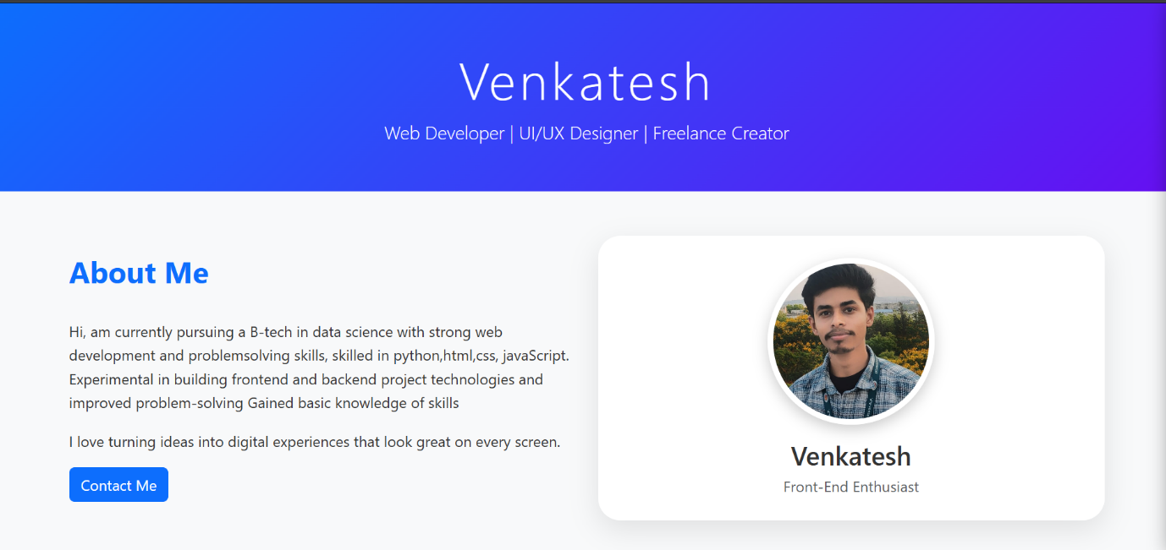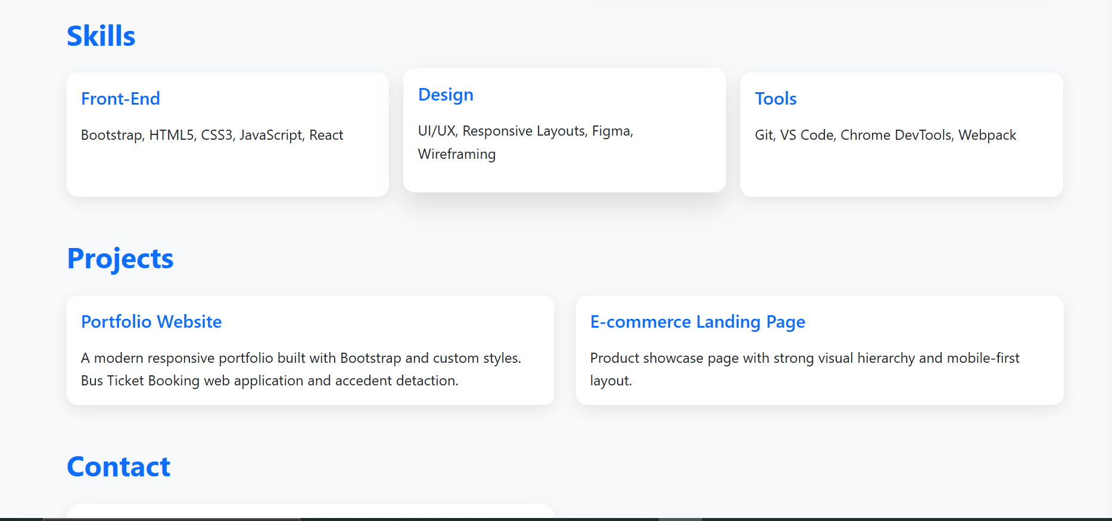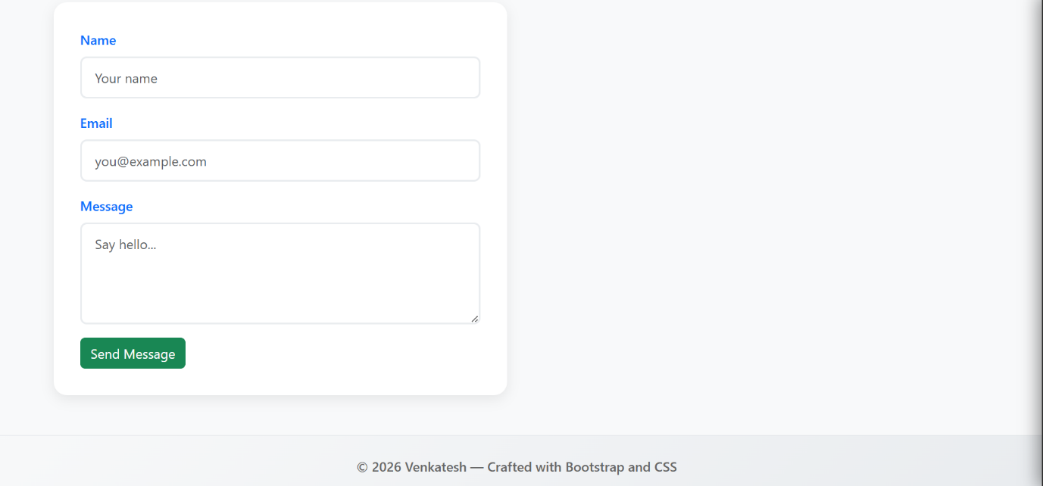

Result
The responsive portfolio website was successfully designed and developed with a modern and user-friendly interface. The website works efficiently on different devices such as desktops, tablets, and smartphones without affecting the layout or performance. All sections including Home, About, Skills, Projects, Resume, and Contact were implemented successfully with smooth navigation and responsive design features.

